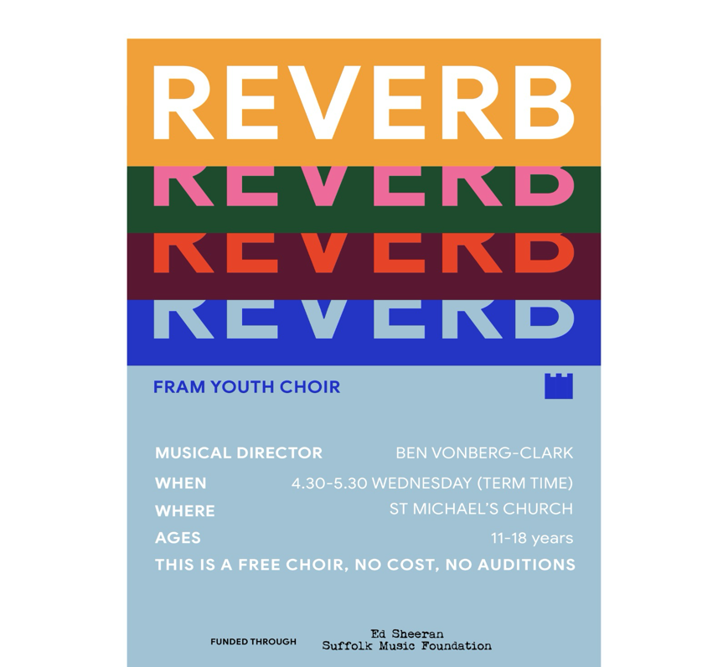
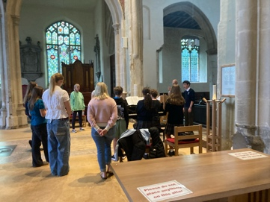


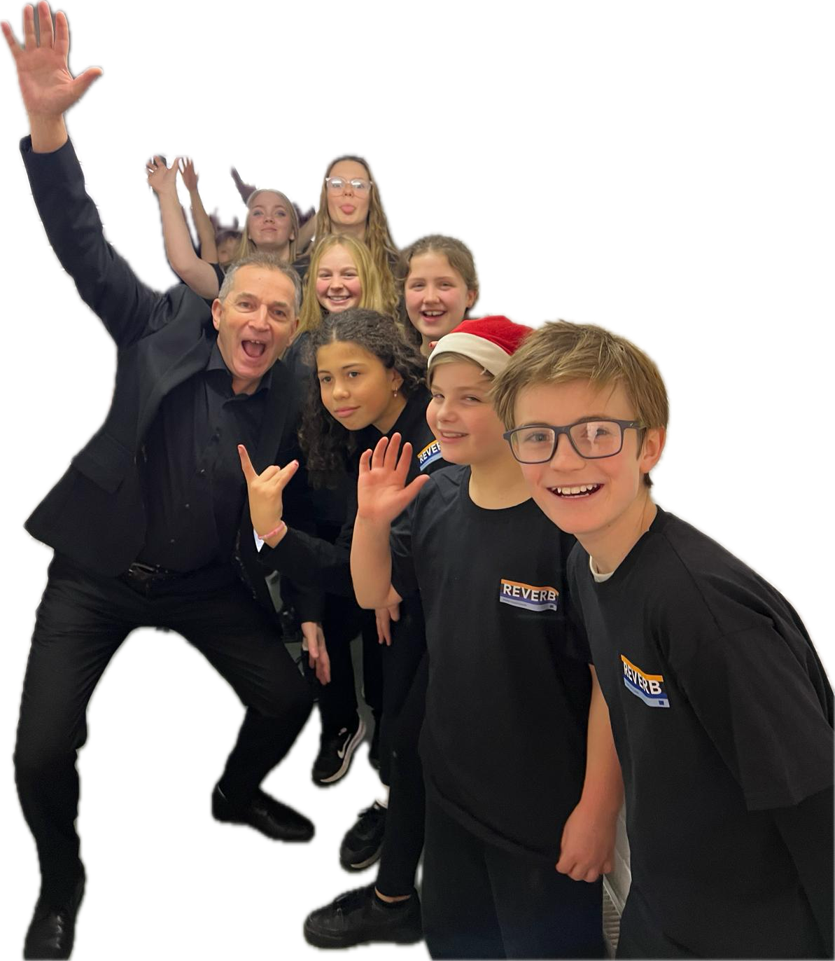
REVERB
A musical journey at St Michael’s Framlingham encouraging young people musical excellence and to engage with their spirituality through song, story, and community.

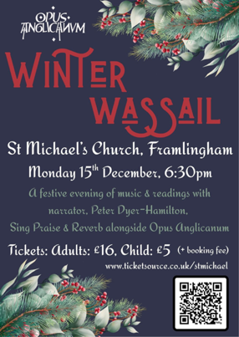
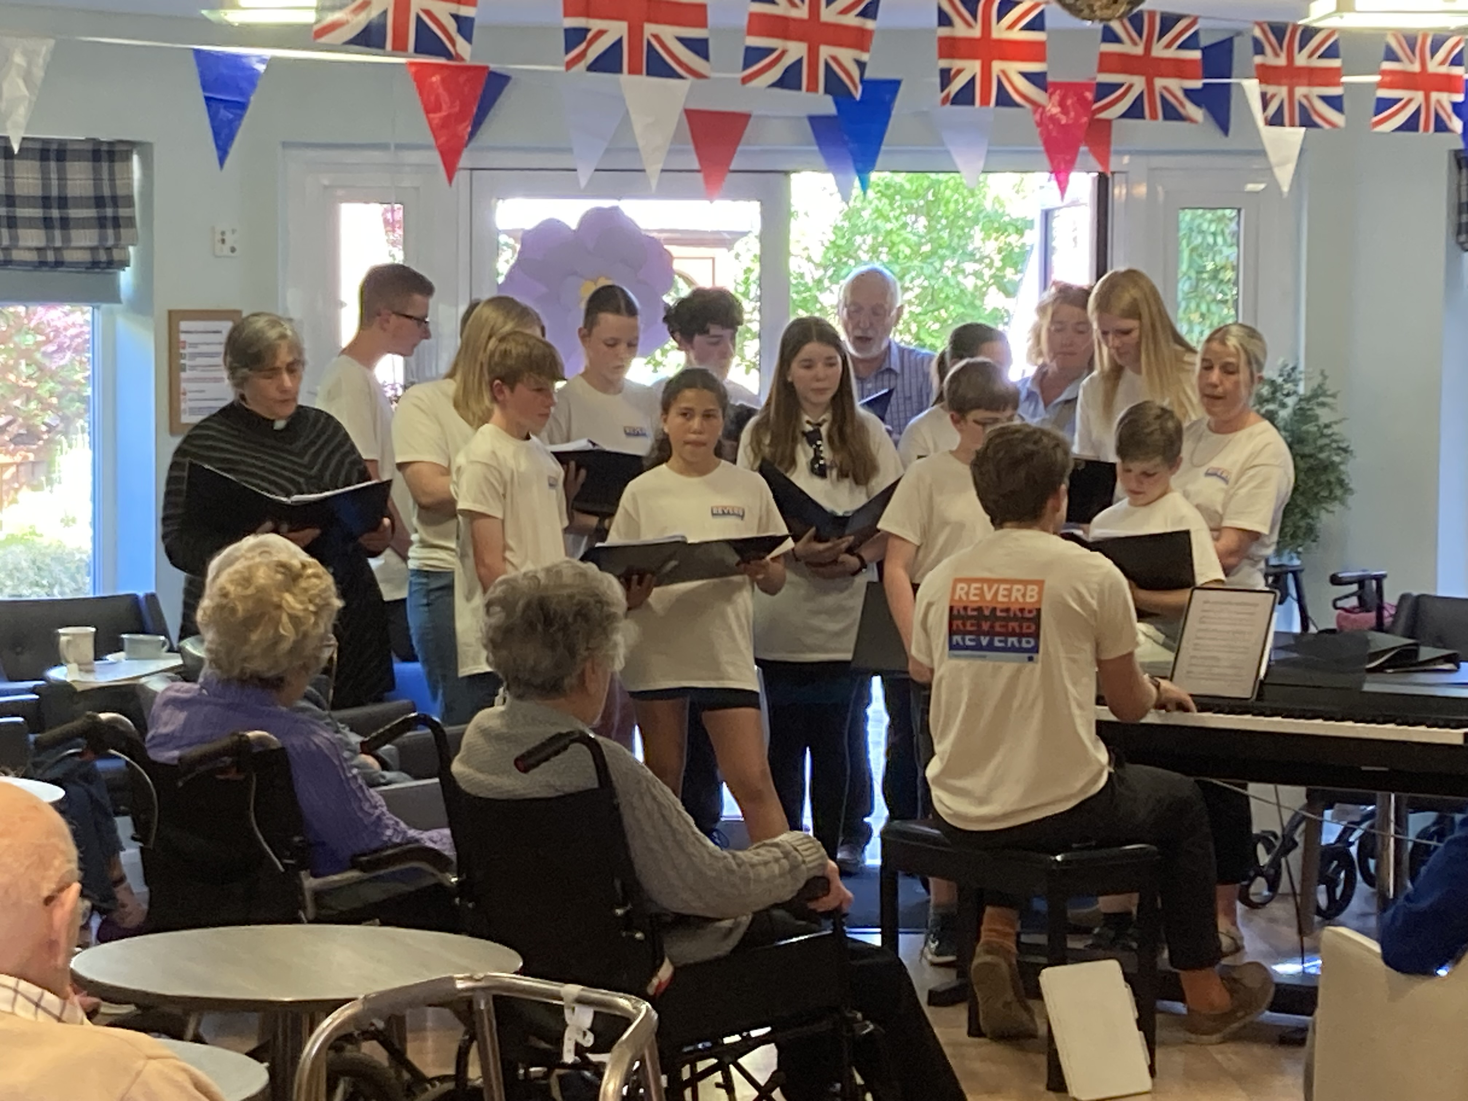
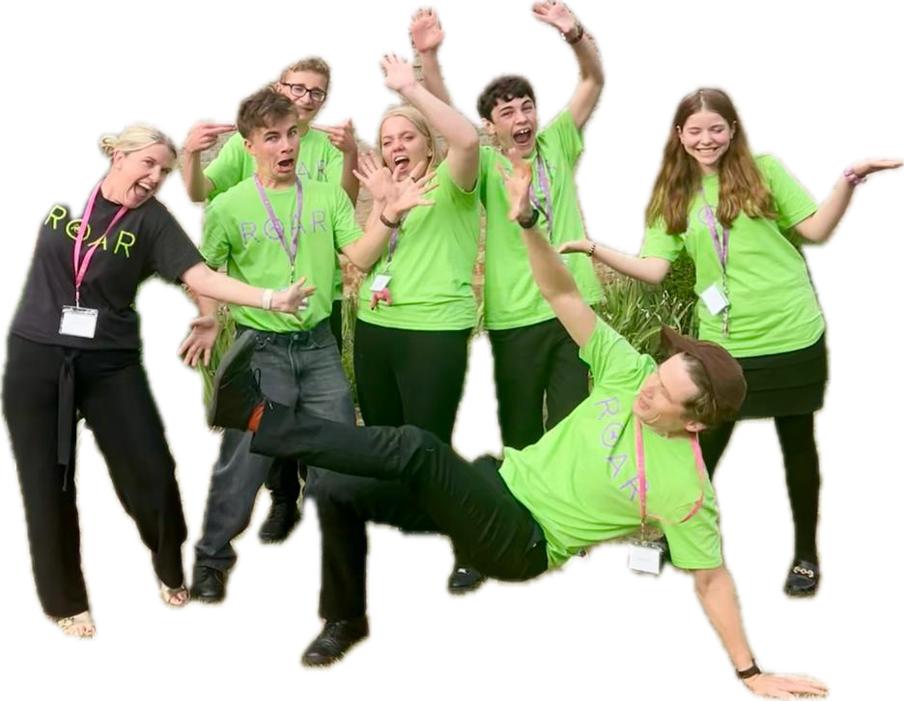
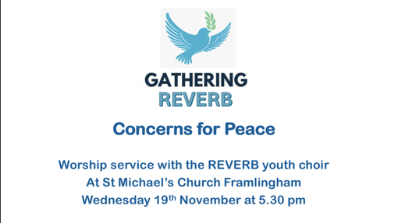
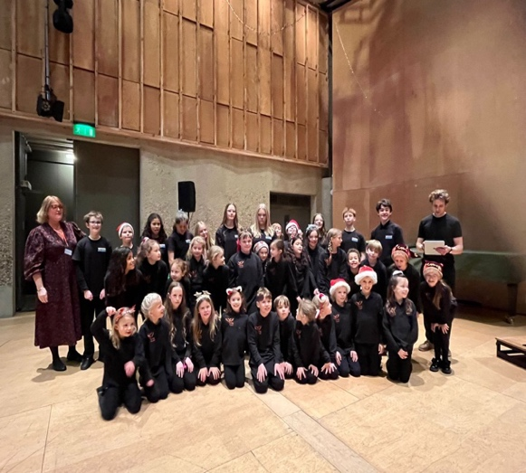
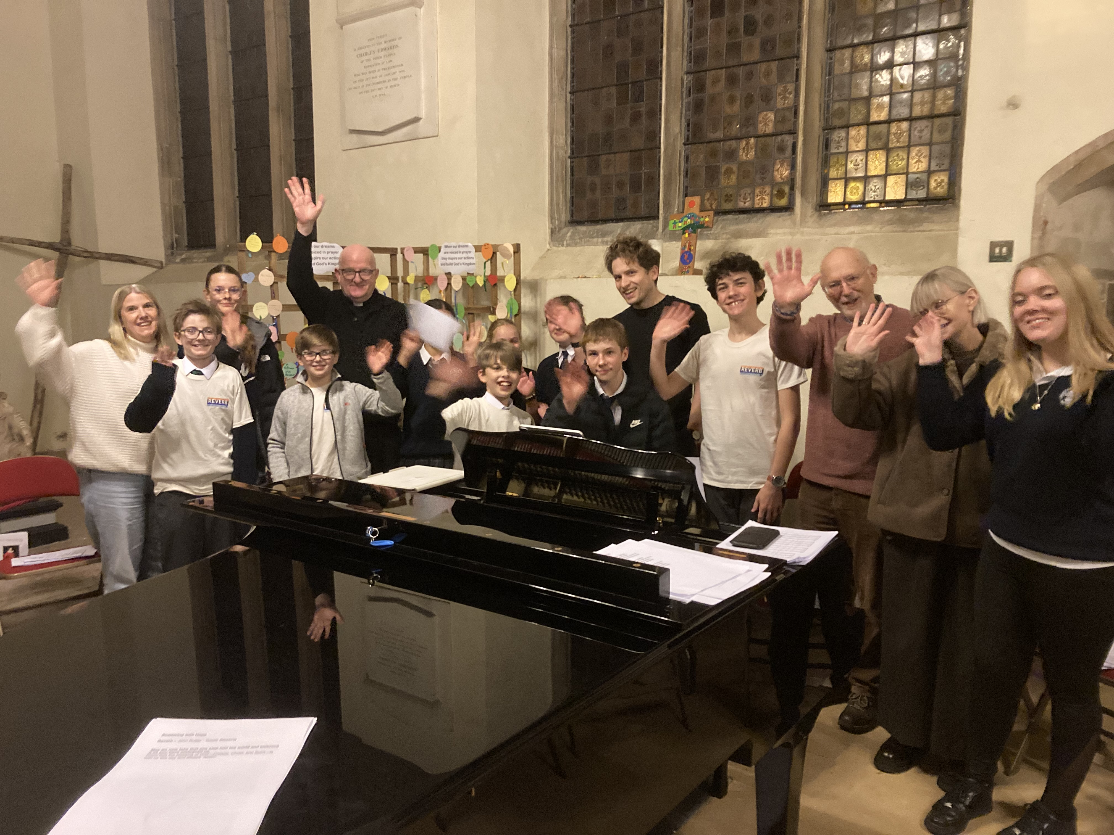
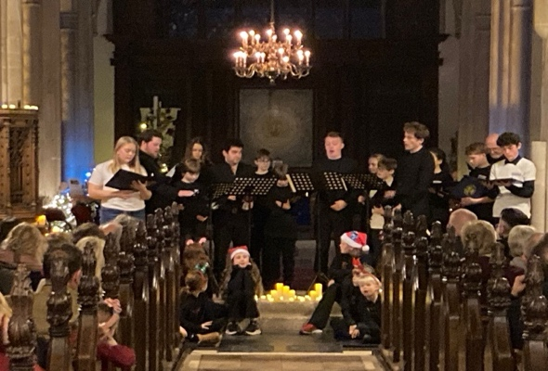
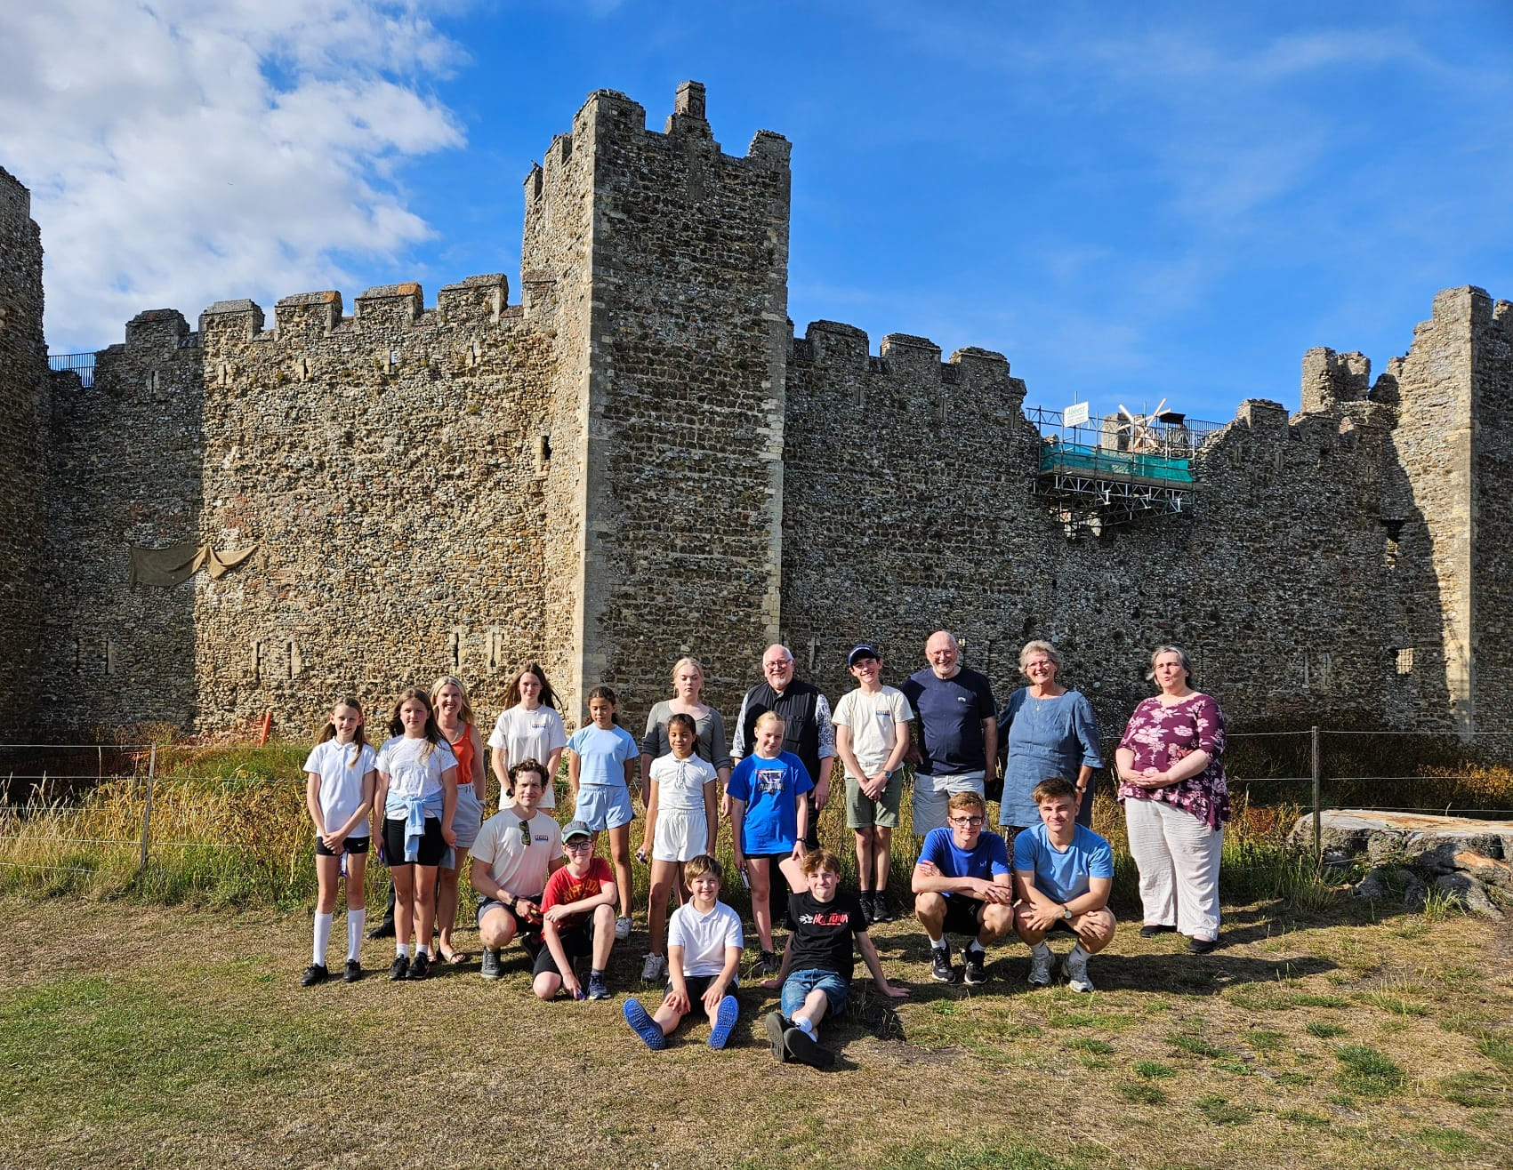
Introduction to REVERB
The origins of the teenage music group date back to 2018, during the development of the Sing Praise project at St Michael’s Church. From the outset, there was a clear vision that the church’s music pathway would include provision for teenagers. This aspiration, initially developed under the working title Song School, became a reality five years later once Sing Praise was firmly embedded in the life of the church and wider community.
In 2024, with the support and encouragement of the Parochial Church Council of St Michael’s, Framlingham, plans were put in place to establish a dedicated teenage music project by the end of the year. We are particularly indebted to Catherine Johnson, Director of Sing Praise, whose commitment and guidance were instrumental in bringing this project to fruition.
We are also extremely grateful to the Ed Sheeran Suffolk Music Foundation for awarding a three-year grant, enabling the project to establish itself securely. The vision was to engage secondary-school-aged young people in a weekly music group that would encourage exploration of faith and spirituality through music. It was recognised from the outset that the appointment of a Musical Director would be fundamental to the project’s success and long-term development.
Following research and consultation, we were delighted in autumn 2024 to appoint Ben Vonberg-Clark as the project’s first Musical Director. Ben brought with him a strong track record of working with and developing choirs for young people, alongside an impressive professional musical background. His enthusiasm and ability to connect meaningfully with young people were immediately evident.
In September 2024, the group – then operating under the working title Cloister – began meeting in church every Wednesday afternoon. Open to all secondary-school-aged young people, the group initially grew from alumni of Sing Praise. Early take-up was understandably cautious, and feedback suggested that the provisional name may have been a barrier. Working collaboratively with the young people, a new name was chosen – REVERB – giving members a strong sense of ownership from the outset.
Ben’s enthusiasm and exceptional ability quickly helped the group to grow. We were pleased that this growth was organic, and that success was measured not by numbers, but by the quality of the experience and enjoyment of the young people themselves. In its first 15 months, REVERB has benefited from a number of remarkable opportunities, which are outlined later in this report.

From our Musical Director
It has been a real privilege to be part of the REVERB journey since September 2024, and I am immensely proud of what has been achieved so far. More than any single musical milestone, however, I take greatest pride in the community we have built – among young people, parents and volunteers alike – in such a short space of time. Music education is vitally important, yet many children today have limited access to it. More importantly still, in a world increasingly shaped by artificial intelligence and digital gaming, young people are seeking places where they can belong, feel seen, and express themselves freely without fear of judgement or diminishment.
While I am deeply thankful for our musical successes – who would have imagined that we would be booked to perform at the Aldeburgh Festival less than two years after the project’s inception – we are equally committed to supporting the individual journeys of our singers.
We have seen young people who were initially too shy to make eye contact step forward to sing solos and accompany themselves on the piano; friendships form across different year groups; and two members confidently navigating the emotional and physical challenges of singing through voice change. These moments speak powerfully to the impact of the project beyond performance alone.
I am profoundly grateful to Chris, Anna, and all our volunteers, who give their time so generously each week and bring such consistency, care and attention to our young people. I have established and led choirs before, but I have never experienced the depth of love and support that surrounds this project in Framlingham. This is an investment that I believe will leave a lasting legacy – not only for the children involved, but for the wider community as well. It represents church at its best: not imposing dogma, but offering an open door, a welcoming community, and first-class opportunities that will remain with us for years to come.
Thank you for your continued support of REVERB. I look forward with great anticipation to seeing where this journey will lead in the years ahead.

Ben Vonberg-Clark

Rector’s Reflection for REVERB
REVERB has been in the planning for 5 years, the next step on the musical pathway at St Michael’s. In 2024 everything aligned and it was the right time for us to launch a new high school singing venture which would become REVERB. We were conscious that this group, although related to Sing Praise, would need to find their own voice and grow organically. We were fortunate that Ben Vonberg-Clark had just finished as Musical Director of a church in West London during which time he had built a large choir with many young people. We were delighted he agreed to be our first Musical Director.
The vision for this group is to enable young people to encounter beauty through music - exploring melodies and harmonies that have the power to lift the spirit in a challenging world. With so many expectations placed on young people, particularly in academic life, it is vital to remind them that life is richer and broader than achievement alone, and to offer experiences that genuinely gladden the heart. This inner space is the home of the soul and the playground of the spirit. Within it, young people are given the freedom and permission to become more fully themselves.
This mystical experience is by its very nature religious, and to ground it in a church community gives us a chance to speak the whispers of eternity into the often-claustrophobic present. Our funding rightly requires REVERB to be open to all, regardless of religious affiliation. This is an important principle, as it reflects the inclusive hospitality that lies at the heart of our life as a church community. To offer a warm welcome, plentiful refreshment and a sense of community as a gift is very valuable in our world today.
What we have seen over the last fourteen months is the capacity of music to build relationship: to transcend age groups or generational boundaries. Under Ben’s unique directorial style an able choir has emerged. We have seen confidence build and personalities shine and flourish. To be able to facilitate this is a privilege. Everything that underpins this work speaks of the God of love and the values of the Kingdom, and through the Gatherings, young people are finding a language to help express both the joys and the challenges of life.
I am deeply grateful to Ben for his inspirational leadership, to Anna Winstone for her tireless co-ordination, and to Mary, Peter, Edith and Caroline, whose commitment enables us to do so much and to do it safely. I look forward with excitement to the next twelve months - to growth in its many forms, and to rejoicing in the power that underpins it all.

The Rev Christopher M. Davey, Rector of Framlingham.
Our Journey So Far – Oct 24 to present
The Gathering. Initially it had been thought that REVERB would regularly take part in the monthly All Age Eucharist on the first Sunday of the month. We realised however that Sunday mornings are not always easy for young people. It was therefore decided to devise a simple evening worship once a half term to allow them to engage in worship in a planned and focussed way. The first gathering in 2024 was around Christmas time and the congregation of parents, family and supporters came out to support their efforts. Gatherings are themed with liturgy, readings, and a reflection to help focus on a particular topic. Further gatherings have focussed on spring and Peace. The Gathering is a fresh expression of worship at St Michael’s, Framlingham and attracts a congregation of about 40.
Sunday Worship – REVERB occasionally support the Eucharist on a first Sunday of the month. Most memorably have been collaborations with Sing Praise and the Church Choir at Easter 2025 with a rousing introductory ‘Alleluia’ which filled the church with sound.
Gabrieli Roar – in the summer of 2025 five of our young people were able to attend a weeklong residential course run by the Gabrieli Roar organisation culminating in a performance in Ely cathedral of Haydn’s The Seasons as part of a five hundred strong choir. Those who attended were able to attend workshops designed to improve their vocal abilities and performance confidence. In autumn 2025, along with the children of Sing Praise, REVERB was invited to sing in the Britten-Pears Arts production of The Snowman. This gave the young people the chance to sing on the stage of the main concert hall at Snape Maltings to an audience of eight hundred people. They worked under Musical Director, Ben Parry, and had the chance to sing with a full orchestra.
Wassail 2025 – in December 2025 REVERB had the opportunity to sing with professional choir Opus Anglicanum at St Michael’s. The evening also saw the youngsters collaborating with Shakespearean actor Peter Hamilton-Dyer. It was a wonderful occasion with an audience of over two hundred people.
As 2026 begins we are looking forward to being part of the enthronement service of the new bishop of St Edmundsbury and Ipswich, where together with Sing Praise, we will sing ‘Feeling Good’ by Nina Simone, identified by Bishop Joanne as her favourite song.
The Aldeburgh Festival 2026 Together with music groups at Thomas Mills High School, REVERB have been invited to be part of the opening of the festival singing with the BBC Scottish Symphony Orchestra. We are delighted to work with Britten-Pears Arts once more.
Also in 2026 we look forward to singing the premiere of ‘Scorched Earth to Green’, an environmental song cycle commissioned by the church for our music projects. Composed by Fraser Wilson, the writing process will involved the children and young people throughout. The premiere is planned for Harvest.

How does REVERB disciple young people?

REVERB seeks to allow its participants to explore spirituality in its broadest sense through music. This is done each week in the fellowship of the group and in worship at The Gathering and occasionally at the Sunday Eucharist. Our discipleship is gentle, and this allows the group to be truly open to all in the community regardless of faith, but broadly we would say:

We disciple through inclusivity and welcome. Hospitality and inclusion are at the heart of REVERB because the group is at the heart of the Church of St Michael’s, Framlingham. We established the project as an act of service to young people; to create a space in which they feel welcome and secure. The church building is a warm environment to meet, and a dedicated team of volunteers are on hand to ensure a warm welcome, and to provide hot chocolate, homemade cakes, and an ear should it be required. Our volunteers include three members of the clergy ministry team, a church warden, and an Elder. While some sing with the group, others are charged with welcome and serving refreshment, and enjoy the opportunity to chat with parents and families who come to support. All of our volunteers have undergone safeguarding training, and the project complies with the Church of England safegaurding policies.

We disciple through music. Singing is a spiritual experience. The words we sing and use in worship effect who we are and present opportunities to explore life, feelings, and faith. In the Christian context and through the services and festivals of the church year, we give our young people the opportunity to explore the Gospel. Music, as those who run choirs will know, has the profound ability to disciple people in a unique way reflecting the mystical nature of life. This ability of music in discipleship should not be underestimated or overlooked.

We disciple through example. Our volunteers model kindness and acceptance as core values and we seek to shape REVERB as a nurturing community, both between volunteers and youngsters and peer to peer. Choral singing requires listening to each other, working together, and allowing others to shine.

We disciple by setting faith in the world. We do this by allowing children to see that God is not restricted to the church or even the sacred, by performing secular music as well as sacred in our repertoire. In this way we open the eyes of the whole church family to a God who speaks constantly and unrestrainedly in the created world.

We disciple through belonging and community. REVERB is a community that embraces not only young people and volunteers, but increasingly parents and siblings as well. Through worship, the REVERB family comes to experience itself as part of the wider church family - a place to belong, to be known, and to be loved. As relationships deepen, the perceived barriers between the group, the wider church, and the Framlingham community begin to dissolve, allowing each to inform, inspire, and enrich the other in an ever-deepening journey of shared discovery. This understanding of faith in action is already taking shape. As part of their exploration of Christian service, the young people recently sang for the residents of Mills Meadow care home.

What our young people say:
“Prior to REVERB I attended Sing Praise. I am currently a year nine pupil studying music GCSE at Thomas Mills High School. Both Catherine and Ben have been influential in my choice to do music. In Sing Praise Catherine introduced musical instruments, such as the recorder, and now I am working towards my grade four piano. When I moved up to secondary school, I was pleased to continue my singing with REVERB which gave me the opportunity to take part in a week-long residential trip with Gabrieli Roar, where we sang Haydn’s The Seasons at Ely Cathedral with a professional orchestra. Without the Ed Sheeran Foundation’s support for Sing Praise and REVERB, I might not have had these amazing opportunities. Thank you to the Ed Sheeran Foundation and everyone involved, especially Sandy who makes wonderful cakes” - Thomas
“I like how you sing in the different parts and harmonies and like being able to read the music” – Saskia

“I like how relaxed it seems and the way Ben teaches” - Emily

“I like REVERB because I like to sing in harmony and with a group of friends” - Sturley

“I like REVERB because I like singing but also because of the people who are there” – Elliot

“I like how Ben makes it fun” – Josh

“It’s very fun. It’s nice to socialise and see other ages” – Grace

“I love making new friends and giving me opportunities to sing and play the piano” – Jamie

“We get lots of opportunities to sing with different music groups” – Fyn

“I really enjoy learning new songs and have made many new friends who also enjoy singing. I enjoy being part of a community that's not just my year group and I love the snacks!” – Josh
“I love going to REVERB because it makes me feel happy to let my heart sing” - Sturley
“Everyone's nice and no one takes the limelight. Everyone gets a share. Chris puts in so much work and it is like a meeting place where we sing together, eat stuff and have hot chocolate”.

“It's community, right?”

“Ben's so funny and makes you feel good about yourself”.

What our parents/carers say:
Jaime started REVERB in April and was very nervous about starting a new group, but she has always had a strong interest in singing and music in general. Within a few weeks she really opened up and started to enjoy the group, especially Ben’s passionate attitude and personality, and the ever-positive and helpful Anna when confidence is a little low. Positives have definitely been The Snowman concert at Snape Maltings before Christmas and the Winter Wassail with the amazing Opus Anglicanum, two opportunities that never would have arisen without REVERB and the Ed Sheeran Foundation! I will also add that Jaime was shy about letting me or anyone else hear her play the piano, but now as soon as the session has finished she will happily play in front of anyone that will listen and has just passed her grade 3. I would love to say thank you to all involved, and also mention that the hot chocolates and freshly baked cakes and biscuits are also a winner with Jaime!! Darren R
My daughter has been fortunate to be part of REVERB since its launch. Being part of REVERB has opened up amazing opportunities to Grace. Last summer she was funded by REVERB and Gabrieli Roar to attend the Gabrieli Roar summer school and sing in Ely Cathedral. The funding afforded to REVERB is opening up wonderful opportunities for local children to be part of an encouraging and nurturing learning culture. Grace has experienced sing with professionals as well as with a full orchestra. Singing with REVERB has supported Grace to grow in confidence and feel a sense of achievement. Bev T
I’m really grateful Thomas has such a great support team at REVERB, and it has been a pleasure to attend some of the wonderful concerts. I’d like to say thank you to Anna, Catherine, Ben and Chris for all their help and support that they give all the children. Kelly G
Ben's really great at engaging with the young people. REVERB is giving them lots of opportunities that help grow their confidence

It's a great choir to be able to engage with young people of different ages and work on something together. The team are enthusiastic, always friendly and inclusive, and it's a positive thing for young people to be involved in. P.S. The cakes are always nice 😜 - Tracey

We have loved being part of the services at St Michael's. Having arrived from another continent a year and a half ago, Sing Praise and REVERB have really been a rock for the boys as we've found our feet here. Meeting like-minded individuals, with Josh now having James as one of his best friends, has been a real blessing to our family. To think that we signed them up from Kenya, knowing nothing about Framlingham or Suffolk, it feels like a lifetime ago now but we are so grateful for the grounding it's given us and for the community we've grown to know and love. Rachel J
Sturl loves REVERB - he always leaves with a huge smile on his face. Thank you for the amazing opportunities REVERB has brought for our son, he loves it! - Emma

What our volunteers say:
I have been supporting REVERB for a short while but in that time I have witnessed the relaxed and enjoyable moments young members have singing together and spending time with one another. I am reminded of an understanding that at a young age, taking part in such a group can initially come with apprehension and anticipation so experiencing the group growing together, finding trust and honesty within newfound special relationships, is such a pleasure and a joy. Caroline
I find the sessions with Ben and the children inspirational. To see shy and unsure youngsters given the confidence and the skills to sing in front of others, faces changed from uncertainty to sheer joy in the sounds produced. To see the bonds strengthen between them as they experience the wonderful music they can make together, how Ben’s gifts as a teacher gives them resilience and confidence to make mistakes without fear of mockery. To see the support they give each other – the younger members mixed with the more experienced. It is a most wonderful and generous gift that the Ed Sheeran Foundation is giving to these youngsters and a real blessing for our church family as they share their voices within our worship. To see how comfortable they are within the church and the services is a truly amazing experience. Rev Mary Lamb
It has been a joy and a privilege to be a part of this project at St. Michael’s church. I am passionate about the many benefits of singing and singing in a group in particular and so it was lovely to be asked to participate and support this initiative.
Attending every week, I have seen the group grow in confidence. Individually many of them have blossomed and literally found their voice and as a group they are really starting to gel and interact with each other positively, not just when they are singing.
Ben Vonberg-Clark is a huge part of this and exudes enthusiasm and positivity. He is an incredibly professional musician and singer as well as being up on all the latest digital resources available to help with a project like this. He leads the group in such a way as to include everyone and encourages those who are a bit slower to come forwards. He is sensitive to the different personalities and some of the learning and behavioural difficulties that are present among the group and works with them so that they are able to perform to a very high standard.
It is also brilliant that Anna is part of the team and is able to organise and support the group in so many different ways with several different “hats” on. Her contacts have enabled some of them to attend the Gabrieli Roar summer school which had a huge impact on those who went and was a great opportunity to work with some wonderful singers and conductor, and to sing some music that they would otherwise not be able to do.
The group have also had great opportunities to sing at the world-renowned Snape Maltings Concert Hall and have been asked to sing at St. Edmundsbury Cathedral for the enthronement of the new bishop in January 2026.
These opportunities have come about by the dedication of the team running the project, but also through the hard work and focus of the young people involved. We have a lot of fun, but we also do the work together and I am proud and privileged to be a part of it. I’m looking forward to seeing what the future holds for this group and trust that it will continue to grow and develop in the skill of making beautiful music together wherever they are. – Rev Edith Peck

I love volunteering for REVERB. Over the past year, we have built a small but dynamic community of young singers, and it has been incredibly special to witness their growing confidence and developing sound.

I feel very fortunate to work with the support of St Michael’s Church, and with Chris Davey’s passion for ensuring teenagers have a genuine 'safe space'. Each week, young people are warmly welcomed into the church, greeted with hot chocolate and cake, and made to feel that they belong. Chris’s consistent 'yes' attitude has enabled the choir to take part in high-quality musical experiences, including working alongside a professional orchestra and singers.

Ben Vonberg-Clark is a force to be reckoned with. The relationship and trust he has built with these young people is exceptional. They trust him implicitly, he challenges them musically, and in return they show respect, commitment, and a determination to make him proud.

It is a pleasure to work alongside this team, coordinating administration, communicating with parents, and managing social media to ensure our young singers receive the recognition and opportunities they deserve.- Anna Winstone

It's great to see young adults coming week by week to sing under the brilliant guidance of Ben. It's great that it's encouraging 'non-church' families to be involved with the church. The youngsters clearly enjoy what they are doing and getting a lot from it. Peter Lamb

What the wider church say:
REVERB at St Michael’s, Framlingham, is doing wonderful work – drawing young people into worship with joy, confidence, and a deep sense of belonging. It has been a personal joy to join them in worship over this last year and to see music and faith come alive for a new generation. Ven Rich Henderson, Archdeacon of Suffolk.

What our musical partners say:
Sing Praise and REVERB Choirs with Britten Pears Arts
The Children, Families and Young People department at Britten Pears Arts manages many projects and initiatives to support young people in music, from creating and exploring to performing and recording.
We were delighted to work with the wonderful children and leaders of Sing Praise and REVERB across multiple projects in 2025. These included a recording project for the much-loved Friday Afternoons song bank, as well as an exciting Christmas performance opportunity as part of The Snowman. This saw the choirs perform on the world-famous Snape Maltings Concert Hall stage with a live orchestra.
Over the summer, Catherine Johnson led the learning of not one, but two brand-new songs written by composer Jessie Grimes in collaboration with school children in Dublin and Belfast. Sing Praise learned ‘Tale of the Titanic’, a poignant and heartfelt telling of a fictional survivor called Mary O’Hale, and ‘Celebrate St Patrick’s Day’, a jaunty ode to the patron saint of Ireland. These performances completed the submission of five brand-new songs from across the British and Irish Isles to the Friday Afternoons song bank.
The children learned the melodies and lyrics off book, including some Irish words. They focused well, stood professionally, and performed to a very high standard, accompanied by professional pianist Nathan Williamson and recorded by sound engineer Mike Challis. Despite the presence of recording equipment, the children were calm and confident, quickly understanding the protocols that come with recording, such as staying still, avoiding noise, keeping in time, and following Catherine’s leadership and the accompaniment. It was a big ask on a hot summer day, and they rose to the challenge brilliantly.
The recordings have since been published as the official demonstration tracks for these songs on the Friday Afternoons website. This ensures that choir leaders and teachers can hear how the songs can sound, helping children all over the world to learn them.
Later in the year, Sing Praise and REVERB took part in The Snowman, learning three songs for the performance. They carefully balanced their rehearsal time alongside other Christmas repertoire that term and attended a special rehearsal in the Britten Studio at Snape Maltings in November. This gave them the opportunity to walk on stage and rehearse the songs with support from Britten Pears Arts vocal leader Stephanie Wakeman.
The groups performed superbly on the day. Many shared in the post-performance survey that they had never performed with a live orchestra before, and spoke about feeling both nervous and excited to sing on stage in front of such a large audience. We hope they had a truly memorable experience, and we know how special it was for families to watch. I certainly shed a tear or two from the side of the stage.
We look forward to continuing our relationship with the wonderful Sing Praise and REVERB youth choirs at Britten Pears Arts, and to future opportunities in 2026 and beyond. We are excited to continue this collaboration and our shared mission to ignite a lifelong love of music and singing in all the young people we work with.
Hattie Coupe
Programme Manager, Children Families and Young People
Britten Pears Arts

It was absolutely fantastic to collaborate with Sing Praise & REVERB. They brought real energy to our performance. To have them singing a concert of mostly Mediaeval Christmas music at such young ages and enjoying it was nothing short of remarkable. I know the audience was similarly amazed and impressed. I can see that both choirs have very bright futures. – David de Winter, Musical Director of Opus Anglicanum
It was a real pleasure to work with the young voices of Sing Praise and REVERB for two recent projects - the first, a recording of nursery rhymes for the library music company, MediaTracks. The young singers of Sing Praise were extremely well prepared and their discipline and enthusiasm throughout the recording session was exemplary. They managed to record seven tracks in various formats and were great unto work with.
More recently, both choirs participated in a concert at the Snape Maltings Concert Hall, singing as part of the The Snowman Christmas Concert. For this, they performed three songs, including the famous “Walking in the Air” section of The Snowman film. Again, their professionalism shone through in the performances, which were very well received by the sold-out audience.

Ben Parry, conductor and composer

It was a great pleasure to work with five members of REVERB at the Gabrieli Roar Summer Residential course in July. They joined over two hundred teenagers from across the country, representing a wide range of schools, youth choirs, and cathedral and church choirs, for an intensive residential at Gresham’s School. The week culminated in a performance of Haydn’s The Seasons at Ely Cathedral, alongside our professional Gabrieli Orchestra.

Throughout the week, the singers took part in rehearsals with our Creative Directors, received coaching from our excellent team of vocal coaches, and attended a wide range of masterclasses, including score reading, conducting, and composition. They also participated fully in the social programme, including the much-loved Gabrieli Roar Talent Show, and each singer received an individual singing lesson.

I greatly admire these young singers for taking part after only a short time singing with REVERB and for throwing themselves into every aspect of the course with enthusiasm, commitment, and passion. Their professional-level performance at Ely Cathedral was a powerful testament to their hard work and their sense of pride was thoroughly deserved. I very much look forward to welcoming them back in July 2026 and hopefully welcoming even more singers from REVERB.

Paul McCreesh, Artistic Director & Conductor, Gabrieli Roar

