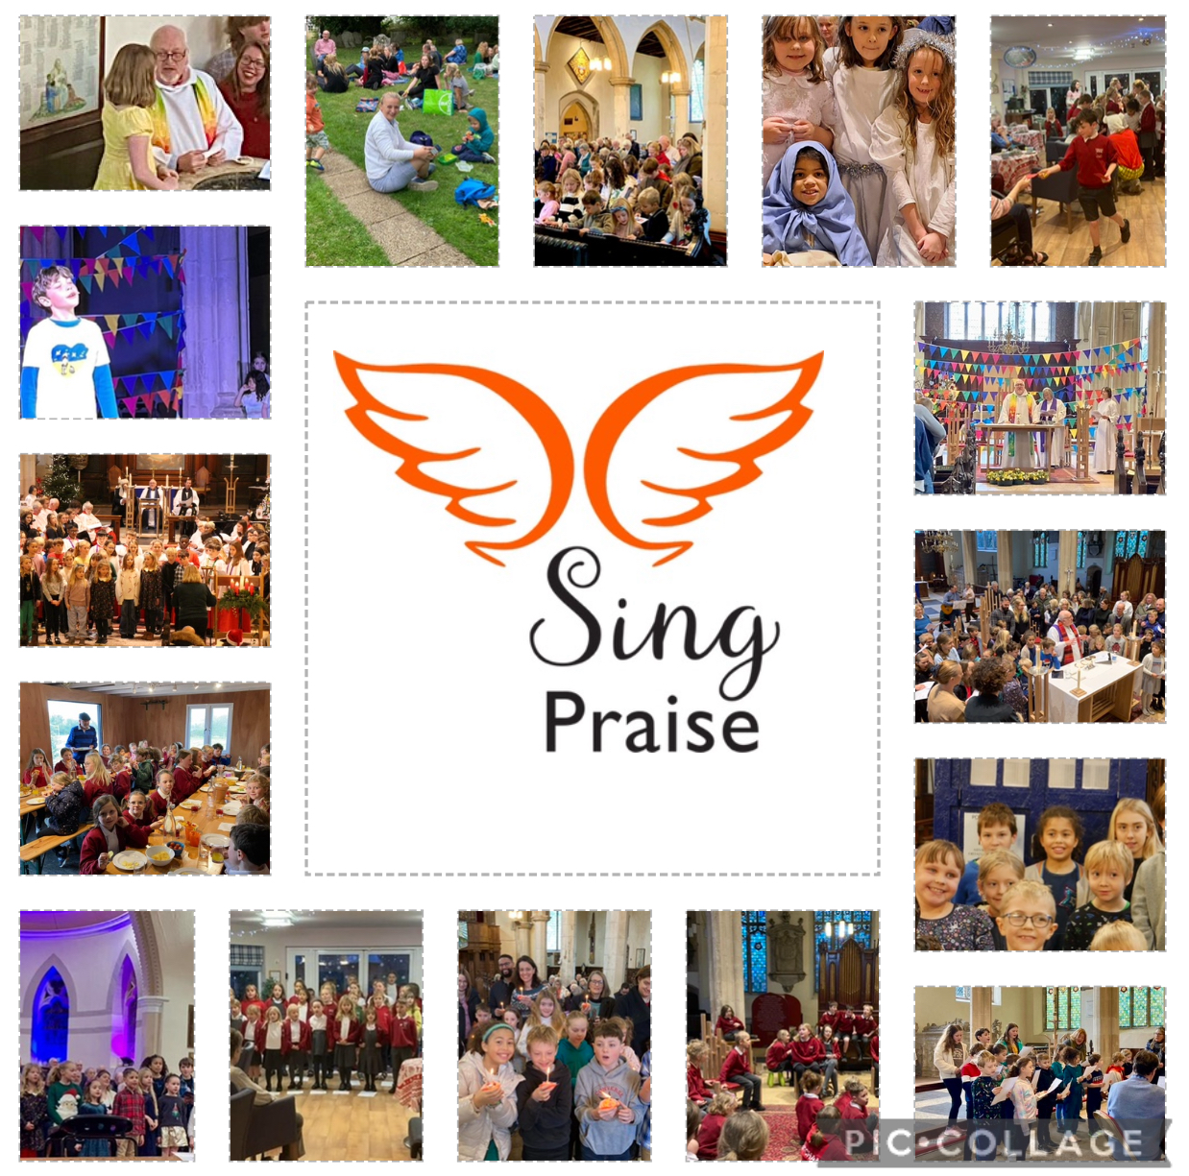

at St Michael’s Church Framlingham.
A musical journey encouraging young people to engage with the story of faith and to encounter God through song.

Sing Praise began life in 2019 with the stated purpose:

- To build on the foundations of daily faith-based school singing through two special weekly sung assemblies in Sir Robert Hitcham C of E VA primary school.

- To provide a church led after school club, especially in relation to choral singing at the family and festival services.

- The Sing Praise Director would help to forge closer links between the school and church.

Sing Praise meet each Tuesday in term time from 3.30 – 4.30 pm for singing, refreshments and fellowship. Sing Praise has a paid Director who is a music specialist, and we are funded in the main by a generous annual grant from the Ed Sheeran Suffolk Music Fund.

Although we remain true to our founding principles there have been changes to how we work since lockdown. Importantly, unused Sing Praise funding has been used to pay for our Sing Praise Director to be implanted in school for one and a half days a week for the last two years at no cost to the school. She is fully utilised in enhancing and enriching the school music provision across all year groups as singing and its effects on emotional well being are well rehearsed and coming out of Covid it felt that this would be a valuable service to our school and wider community. This funding pot is now nearly exhausted, and the school are exploring possibilities about how to continue to fund the work as its value is gratefully recognised.

Since it began Sing Praise has continued to play an important role in the church monthly all age worship service. Also, since the beginning there has been (outside of Covid) an annual production. The Three Trees (2019), The boy, the mole, the fox and the horse (2022), The Selfish Giant (2023) and in 2024 LoveSong. All of these have had very deep Christian themes and values running through them. The annual production is an important part of our life together.

Developments since the Sing Praise journey began:

Coming out of Covid it was decided to move Sing Praise from the school premises to the church building. In part the church building gave a large well-ventilated space but more importantly, a space outside of school would allow children from other schools and Children who were home schooled to attend.

Meeting weekly in St Michael’s church gives the children a sense that the building is theirs. They become comfortable in it, familiar with its layout and acoustic and that all helps to build confidence when the children are taking part in worship. The Church also provides the performance space for the annual production.

The All-Age monthly service is now very firmly Eucharistic. The Eucharistic tradition of St Michael’s is strong and so now our monthly All Age Services are individually crafted to include the music of Sing Praise so that the words of the song/songs that the children are singing are woven into the liturgy and picked up in the sermon to reinforce the message and to make the Sing Praise Choir instrumental in delivering the good news. Our Eucharists are fully inclusive, we practice open table and everyone, regardless of age, is welcome to receive communion and the majority of our children do. The Children also regularly lead the prayers and read. This development has resulted in the engagement of families, parents, siblings and even grandparents attending the service and taking part in worship and staying for refreshments afterwards.

We have used gentle exploration of the songs we choose in worship to ask why it might have been chosen. What does it add. This is the beginning of theological reflection and the use of secular songs helps children to understand that God is present in the whole of life speaking in everything. Use of journaling, particularly during our production of The boy, the mole, the fox and the horse was particularly powerful in allowing children to explore their emotional health as Covid restrictions were lifted, but also to explore those places where life and faith intersect.

Two of our children asked if they could be baptised, this happened organically through their engagement with the church family. We were delighted to baptise them during the monthly all age worship and welcome their wider families and friendship groups into church.

We have increased the number of children we work with in Sing Praise from 30 to 38 and this is in part thanks to a very loyal and faithful group of adult volunteers who assist week by week.

We do cater intentionally for children who may not access other Framlingham provisions. This is a joy to us and something we are conscious of and intentional in.

Our relationship with other musical expressions locally is growing. In 2022 the children were invited to perform with Christina Johnson, an international soprano at a concert in St Michael’s. We have also sung with the Phoenix singers and will sing with the Suffolk Albion Choir after Easter 2024. We have developing relationships with Pears Britten Arts and Gabrieli Roar. We have encouraged the children to experience other voices in worship including Soloist Claire Weston, Fraser Wilson, and Choirs from Framlingham College, St Mary-le-Tower and singers from across the diocese in the Advent Service in 2023. All this increases our opportunities to perform and build confidence within the context of worship. We have been invited by the diocese of St Edmundsbury and Ipswich to be part of an ongoing discussion and exploration of music as mission and we are in dialogue with the Cathedral Music Trust about the work we do. Our director has been part of a Framlingham cooperative approach through its schools and community groups to provide opportunities for music events designed to bridge primary and secondary school communities in song.

Challenges and future opportunities

We have a long waiting list of children wanting to be part of Sing Praise which is encouraging for us but identifies a deeper need. The funding we already have in place is sufficient for the work we do. The church provides the physical space as part of its mission to children and young families, and we are very grateful to the Ed Sheeran Suffolk music fund for their on-going financial support.

We are aware that most of our children attend the Church Primary School but are conscious that primary school aged children in Framlingham also attend other schools and, a small but growing number, are home schooled. The community that Sing Praise offers could be very valuable to home schooled children. This is something we are aware of but don’t at this time have the financial resources to tackle in a sustained way.

We are increasingly receiving invitations to sing with other groups and artists. This is an affirmation of what we do musically, but we are also we aware of the many time pressures our Sing Praise families experience and our director is keen that we have a balance and that our focus remains worship but that we are open to invitations when they are offered.

Greater integration into the life of the church. It was hoped that Sing Praise would be a seedbed into the more formal choir at St Michael’s and for a time we had three children who joined the church choir. However, this did not prove particularly successful, and we recognise that for this to be a real possibility we would need to be able to attract and fund an organist and musical director with proven skill in this field in the way Chris Borrett has at St Mary-le-Tower in Ipswich or music provision at St Edmundsbury cathedral. Until we are in a position to do that we will continue to do and develop what is working well and enjoy the fruits of what is growing in our midst.

Long term sustainability. We are acutely aware that Sing Praises success is in large part due to the calibre and personality of Catherine Johnson, it’s first Director. Catherine brings an energy and enjoyment to the role which is infectious. As a Christian and active church member herself she forms a very natural bridge between project and church so that the boundaries between the two are dissolving in a way we dare not have envisaged. Replicating this would be a challenge. Funding at its present provision is adequate but to build greater provision we will need to look for other funding streams.

How does Sing Praise disciple young people?

We disciple through inclusivity and welcome. Sing Praise numbers are only limited by resources both human and financial. We do not audition, and children of all abilities and any faith are welcome to join. There is a very clearly stated requirement that Children attend and take part in All Age worship. Our Church building on Tuesday afternoon becomes their home, a space is warm and safe, the Church regard this as an essential element of its mission to children, young families and the local community. Sing praise has a clear commitment to safeguarding and the clear boundaries and expectations are in place to allow everyone to feel at home.

We disciple through music. Singing is of itself a spiritual experience. The words we sing and use in worship effect who we are and present opportunities to explore life, feelings and faith. In the Christian context and through the services and festivals of the church year we give children the opportunity explore the story of Jesus and the message he comes to bring in an intentional way. Music, as many who run choirs will know, has the profound ability to disciple people itself in a unique way reflecting the mystical nature of life. This ability of music in discipleship should not be underestimated or overlooked.

We disciple through example. Our sing praise volunteers are in the main church members. Kindness and acceptance are at the heart of our core values and we seek to shape Sing Praise as a nurturing community both between volunteers and children and peer to peer. We encourage and recognise older children to be watchful and careful of younger children. This might be on the walk from school to church, the mixing of age groups for crafts and games or helping younger members with refreshments. Choral singing itself requires listening to each other, working together and at times allowing others to shine.

We disciple by setting faith in the world. We do this by allowing children to see that God is not restricted to the church or even the sacred, by using secular music in worship we open the eyes of the whole church family to a God who speaks constantly and unrestrainedly in the world and recognised and celebrated more intentionally in the church.

We disciple through belonging and community. Sing Praise is a family, incorporating not only children and volunteers but increasingly parents and siblings, and in some instance grandparents. Through worship the Sing Praise family experiences itself as part of the wider church family, a place to belong and be loved. As relationships build the perceived walls between the Sing Praise Family, the wider church family and the Framlingham community family hopefully dissolve so that each may inform, inspire and cross pollinate the other in an ever-deepening journey of discovery. The children regularly sing at community events and in Mills Meadow care home as part of their understanding of Christian Service.

What our Children say
I like it that everyone is welcome, and help you build your confidence. It ok to have a go at new things and it is a lot of fun, we are like one big family. I feel supported and know that I could talk to any of the adults and they would listen - Zara 8
We love Sing Praise because we love singing, acting and the chance to do solo’s and dancing in services and productions because it’s fun – Adriana and Viviana 8 & 10
It’s hard to pick my favourite things are there are so many! I like being with my friends and the easier songs because I don’t have a very good memory – Lucas 11
I like how everybody works together and unite in our singing. I love everything about Sing Praise really. – Darcy 10
I like it when we do all the singing at the end and our parents are there and can listen to us. – Theo 7
It’s very active, we are not just doing one thing. I like that we have celebrations after we have done something well – Iris 8
Sing Praise was a bit scary at first but now it’s really good and I get to be friends with people I’m not friends with at school. – Harriet 6
I love all the different songs and singing them makes me feel happy on the inside! – Theo H 6
Sing Praise is a fun place where you can express yourself and where you don’t have to feel shy to do things. – Fyn 10
Sing praise let’s you express yourself and be free – Arthur 10

What our parents say:

“My daughter has been doing Sing Praise since September and has really enjoyed her Tuesday afternoons. She’s gained in her musical confidence through the opportunity to sing frequently in the monthly family service and was also inspired by the joint performance with the Phoenix Singers in December. I’m so impressed with Catherine and the whole SP team for their professionalism and enthusiasm (plus biscuits and squash!) Cece’s singing has notably improved and the whole family is keen to attend church on a Sunday due to its inclusivity and friendliness.” - Annie Rogers

“Sing Praise has done wonders for my daughter’s confidence; Sing Praise is like one big family. We all help each other and very it’s a special group, in which the children grow in confidence as well.” - Nicky Hill

“My daughter really enjoys each week and gets so much from it. Over the past two terms, we have really seen her confidence grow - you could previously have described her as shy and she would have been reluctant to leave us to get up in front of people to do things, however, since she has joined Sing Praise, we have seen her confidence soar. We really believe that the format of Sing Praise, with the ethos and approach, regular sessions and contributions to services and other events, has led to this.
It has supported her to grow and be more involved in the community. Plus, we often hear the songs at home too, which is indicative of the levels of happiness that it brings her. She often wants to include us or her younger brother in singing the different rounds, counting us in - her musical knowledge and confidence is definitely expanding too!
Thank you so much for all that you do to put Sing Praise together - I hope that she will continue to benefit from it for years to come, as I know that she emulates the older singers too.” - Amy

“Sing Praise is a wonderful initiative which provides an opportunity for children to sing outside the classroom, connecting them with their local community and church. It is a safe space in which my child engages in different choral music and supports her social and personal development. “ - Anna Winstone

“My daughters have been members of the Sing Praise group for the last four years. They have benefitted from the energy, creativity and joy of the sessions. They have loved taking part in the performances, and the participation in church services has helped to build confidence. There is a wonderful sense of community in the Sing Praise group, and the leaders have a brilliantly ambitious and original approach to the musical output of the group. The result of this is that the kids’ performances are very impressive, especially considering that it is open to all (and some are very young!) And the leaders are endlessly patient and caring - great ambassadors for the church - helping to integrate the community into the church.” – Alys

“Sing Praise is a greatly valued extra curriculum activity our 10 year old twin boys Arthur & Fynley love to be part of.

The team are amazing and engage in such a fun way. The sense of community spirit wonderful. It's a great way to bring school and church life together in a fun, positive and creative environment.

This club promotes great teamwork, builds confidence and the ability to work with all ages. Adults and children of all primary ages interact socially and enjoy drama, music, crafts and learning about Christianity.

My son Fynley has Dyslexia, and the reading, singing and creative actives help him so much with his self esteem and confidence. Sing praise allows much needed creative expression and gives the children a chance to work with professionals and musicians alike”. -Tracey

“Matilda has been attending the sing praise after school sessions for over 3 years now and throughly enjoys every week. As her parents we have seen a noticeable difference in her confidence and joy for music. She has loved being a part of the plays, concerts, family services and overall sing praise family. So much so that even asked to be christened and helped arrange her own baptism!
Thank you to everyone involved with the project, our children are very fortunate to be given these opportunities.” – Hannah Barton
“We feel very privileged that Theo has been given the Sing Praise opportunity. Both music and the church have been real influences in my life, and it’s so wonderful to see Theo embracing them too. It’s been many years since I’ve seen a church so full of young families and at the heart of the community. It’s clear that Sing Praise and the warm welcome that Chris gives are to thank for that. I have fond memories of singing in church myself and it gave me the confidence to play live music as I grew older. That’s enough about me, but as a parent it’s a pleasure to see your child following the best parts of your own childhood. Beyond the church, Theo and our family now have a wider friendship circle and he’s had the experience of singing in the prestigious event at the college.
All’s left to say is thank you to Chris, Catherine, Elaine and the funders. Looking forward to creating many more memories to come and setting Theo up for spiritual and musical success in his life.” – Chris Hendrickson

“My children really enjoy Sing Praise! It is an after-School Club that allows them to express themselves artistically through singing, acting, dancing and performing in a very positive, supportive and friendly environment.

All of the Sing Praise team are wonderful in bringing out the best in the children while allowing them to express themselves and also learn about the Christian faith.

The plays that the children have put on have been marvellous and Catherine and Chris are amazing in what they do creating the music and scripts and sharing them with the children, parents and wider congregation.

We are very lucky to have just an enthusiastic, energetic and talented group of people leading the Sing Praise group and hope it can continue for many years to come.” – Gabriella

“Sing praise is a wonderful place where children are exposed to a number of different styles of music and singing. Learning to sing in rounds, harmonies, in different languages and encouraged to sing solo. An experience that some so young would rarely get elsewhere.

It is a friendly, caring environment and the children are all happy and well supported by adults that volunteer.

Sing praise has provided the children with the opportunity to perform with many other performers which is superb experience and enabled them to increase their cultural knowledge of different styles of music, such as choral, and opera.

The plays with which they have performed have used different media and themes to encourage their creative learning.

Overall, sing praise is a wonderful place for children within the community” Sarah W

What our leaders say:

“The thing about Sing Praise...it's larger than the children - their skills, socialisation, self esteem, opportunities etc etc. It's also about the love, strength and support within the team. They have kept me going in recent months when life has been challlenging.”- Elaine

“I just wanted to say that it’s been an absolute joy to help with Sing Praise! Chris and Catherine together are a formidable creative force, and the effect has shown in the way I have seen the children grow from a disparate group into a beautifully sounding choir. They now sing so confidently and clearly, and with such clarity! Well done! And I doubt any of them will remain untouched by the Spirit in some way or another.” – Alan

"Little did I realise when joining the Sing Praise team what a life-affirming experience it would become for me. It's a joy and pleasure to be part of such a special group of people and to share in the children's enjoyment and energy. Long may it continue." – Graham

“I feel very privileged to be part of the sing praise team led by Catherine and Chris. To see the children grow in confidence and courage is an absolute joy. It is the highlight of my week and is valuable on so many levels for everyone involved” - Sarah

What our church say:

‘Nurtured by Catherine and her team, Sing Praise children and their families have become an integral part of church life here at St Michael’s where they feel happy, safe and secure. The children exude confidence whether singing, dancing or reading and their infectious enthusiasm unites us all through thought, fellowship and fun; the very essence of family worship.’ – Caroline Foster, Churchwarden

What our Church Primary School Say:

“Catherine Johnson has been delivering high quality specialist music provision at SRH since September 2018. As a school, we cherish the impact of Catherine being enveloped in our school family, where the benefits of music have always been acknowledged and prioritised. Having Catherine onboard enables us to increase our offer to the children, specifically keeping within the Sing Praise brief, that of developing the skills involved in singing through worship and enriching our links with our church – St Michael’s.” – Kate Mawson, Music Lead, Sir Robert Hitcham C of E VA Primary School.

What our community say:

“I am very pleased to confirm that we have held a series of lantern making workshops with the children at the Sing Praise group sessions in the Church for our Christmas on the Hill festivities, several years running. We hope to do the same this year too, as it is such a great contribution to the lantern procession at the town event in December each year.”
Marion Hine
Framlingham Town Council

What our musical partners say:

“Phoenix Singers were delighted when Sing Praise accepted an invitation to sing in their Christmas concert in December 2023. That delight continued on hearing their contribution on the actual evening of the concert.

Not only did they sing two very effective and enjoyable solo items (a piece by John Rutter and a Spanish song) but they also sang solo verses in the congregation carols.

The chapel at Framlingham College was full and it could have been daunting for the young singers. In fact, totally unphased by the occasion, they sang beautifully and with really precise diction, directed effectively by Catherine Johnston.

Not only was it wonderful to hear these young voices but also to see their evident enjoyment. All this at the end of a long and busy term for these youngsters.”

Geoff Lavery, Musical Director of the Phoenix Singers.
“It was a privilege to sing alongside SingPraise! during the Diocesan Advent Service in December 2023. The children rose to the opportunity magnificently, singing their Rutter's Carol of the Children. They sang beautifully and managed the 2-part harmony; responding well to Catherine's direction. Aside from the music, I was impressed how engaged and well behaved they were during the long service, despite not being involved in every musical offering. I wish SingPraise! all the best, as they continue to flourish.”

Christopher Borrett
Director of Music - St Mary-le-Tower, Ipswich.

“I was born and grew up in Suffolk, trained & worked as a professional musician in Dublin, Scotland, and Yorkshire, and then returned to East Anglia to help create and promote music that inspires and connects people.
I have found a musical and spiritual home for this at St Michael's, and am now thrilled to be bringing my choral group Albion (as heard on BBC Radio 3 and at numerous festivals) to Suffolk for the first time.
Not only are the Rector and church leaders welcoming the group in with customary warmth, but we have the exciting and important opportunity to share the stage with Sing Praise.
It is vital (in both directions) for young and professional musicians to come together, because by making music together we will form bonds and open up possibilities which otherwise would not have existed.
It will be a pleasure for us to collaborate with Sing Praise, and I hope it proves another part of the inspirational work of connecting communities which the church is leading with such vigour.”

Fraser Wilson,
Creative Director of Albion Choral.

