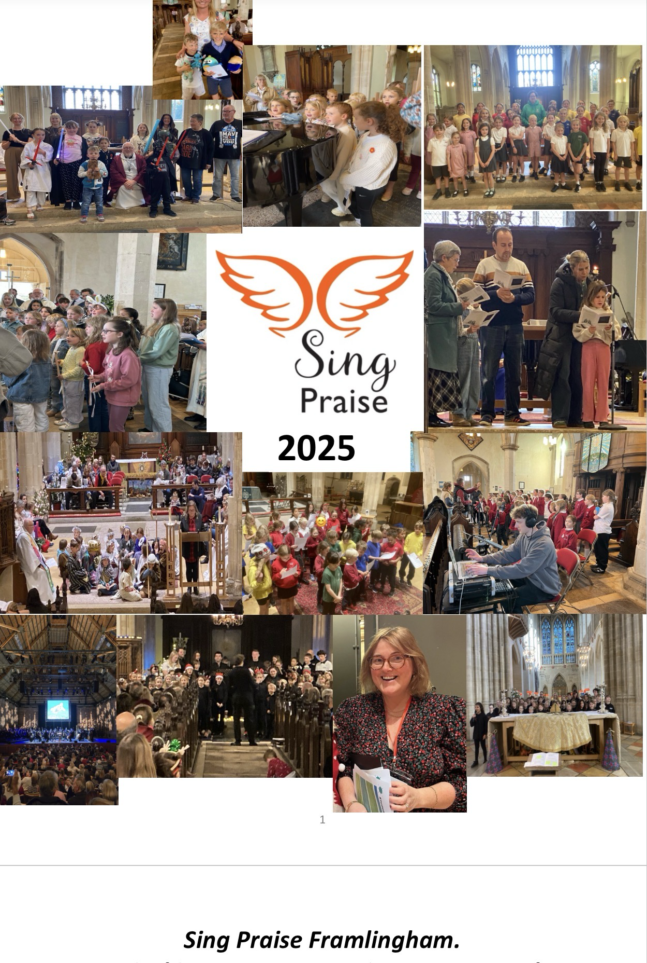
Sing Praise Framlingham.
A musical journey encouraging young people to engage with the story of faith and to encounter God through song.

Sing Praise began life in 2019 with the stated purpose:

- To build on the foundations of daily faith-based school singing through two special weekly sung assemblies in Sir Robert Hitcham C of E VA primary school.

- To provide a church led after school club, especially in relation to choral singing at the family and festival services.

- The Sing Praise Director would help to forge closer links between the school and church.

Sing Praise meet each Tuesday in term time from 3.30 – 4.30 pm for singing, refreshments and fellowship. Sing Praise has a paid Director who is a music specialist, and we are funded in the main by a generous annual grant from the Ed Sheeran Suffolk Music Fund.

Although we remain true to our founding principles there have been changes to how we work since lockdown. Importantly, unused Sing Praise funding has been used to pay for our Sing Praise Director to be implanted in school for one and a half days a week for the last two years at no cost to the school. She is fully utilised in enhancing and enriching the school music provision across all year groups as singing and its effects on emotional well being are well rehearsed and coming out of Covid it felt that this would be a valuable service to our school and wider community. This funding pot is now nearly exhausted, and the school are exploring possibilities about how to continue to fund the work as its value is gratefully recognised.

Since it began Sing Praise has continued to play an important role in the church monthly all age worship service. Also, since the beginning there has been (outside of Covid) an annual production. The Three Trees (2019), The boy, the mole, the fox and the horse (2022), The Selfish Giant (2023) and in 2024 LoveSong. All of these have had very deep Christian themes and values running through them. The annual production is an important part of our life together.

Developments in Sing Praise 2025/26:

Another busy year in the life of Sing Praise with the number of children participating remaining high in the high 30’s and a waiting list. We were pleased that a number of our year six children transitioned easily into our sister project REVERB. We are aware of a younger age range in Sing Praise at this time and that this brings different challenges, especially with regards to concentration after a long school day. We also reflect the increase in children with neurodiverse needs and work hard to encompass them.

We have continued to take an active part in the monthly All Age Eucharist on the first Sunday of the month, increasing the number of songs we use in each service. It is great to see the support and participation of parents, siblings and grandparents on these occasions which allows for greater cross generational input. Children regularly undertake the readings and lead the prayers with musical input designed to support the theme of the service based on the gospel reading for the day.

We were very pleased to be offered other opportunities during the year to expand the experience of our Children. At Harvest 2024 we joined together with the church choir to perform Rutter’s Look at the world.

In March the diocese held a Growing Younger conference at St Michael’s and we were delighted to be asked to be part of the opening worship. The conference was attended by people from throughout the diocese and the children sang confidently and with much positive feedback

On Easter Sunday the children collaborated with both the adult choir and REVERB to fill the church with sound with a glorious Alleluia introit.

When the new diocesan Bishop was announced Bishop Joanne spent a day touring the diocese including lunch at St Michael’s so she could meet diocesan clergy and staff. Sing Praise were invited to sing as part of this welcome. It was a lovely occasion, and the children had quite a bit of time chatting with the bishop before she left and presented her with a Sing Praise sweatshirt which she put on.

In June we had our first of two collaborations with Britten Pears arts when we were invited to record two new songs for the national Friday Afternoon project. The composer and a team from Snape Maltings joined us for the afternoon to record two songs which will be available for other schools across the country to listen to on the Britten-Pears website in preparation for the project later in the year. We sang two songs, one about St Patrick and one about the sinking of the Titanic. The children needed to learn some Irish for this and responded splendidly.

Before we broke for the summer, we were invited to record some Nursery Rhymes for a Suffolk based company. The children worked with conductor Ben Parry and recorded a number of songs. The children were incredibly professional during the recording process and really enjoyed the experience.

In December the children joined with REVERB to sing with Opus Anglicanum as part of the Wassail. It also saw the children working once again with Shakespearean actor Peter Hamilton-Dyer who we first worked with in 2024 when he narrated LoveSong for us. It was a wonderful occasion, and the children sang with their usual excitement and enthusiasm.

On December 21st, together with REVERB we were invited to take to the stage at Snape Maltings for a performance of the animated children’s film The Snowman. It was the children’s second opportunity to work with conductor Ben Parry and a full orchestra. The performance was sold out and the children experienced singing to 800 people including many of their families. What an occasion!

We kick 2026 with an invitation to renew our acquaintance with Bishop Joanne and sing as part of her enthronement service on January 24th at the Cathedral in Bury St Edmunds. During her visit to St Michael’s in May Bishop Joanne shared with the Children that her favourite song is Feeling Good by Nina Simone and so this is what we will be singing for her on the day.

We will also continue during the year to work with Fraser Wilson who has been commissioned by the church to compose an environmental song cycle – Scorched Earth to Green which we hope will be premiered at Harvest 2026.

Sing Praise 2026
As I reflect on what we have achieved this year I really am very proud of each and every Sing Praiser!
I see an increase in confidence, better pitch matching, clearer diction, more focus and fewer social issues as the children learn to be part of the same team.
We have moved at pace this year to fulfil all the commitments we have made to monthly all age worship services, concerts and recording sessions. It has been a whirlwind at times!
These opportunities have presented themselves and we have taken on many challenges. Offering two songs for most all age services rather than just one. Making sure there are solo or small group singing opportunities. We have had two extremely positive recording sessions. One with Media Tracks and one with Britten Pears. We had two sell out concerts in December and got to be inspired by a live orchestra and the male voices of Opus Anglicanum. Particularly inspiring for the boys in our group.
We continue to have the stability of the same wonderful volunteer team. This allows for a safe walk over to church from school and we see some lovely intergenerational friendships grow. The team are regularly briefed on any difficulties the children may be having and know through their safeguarding training to share any concerns with myself and Chris as leaders.
Sing Praise has a history of enjoying refreshments. We have generous donations from parents for drinks and biscuits; we have shared hot chocolate at the local sweet shop and even pizza and party food before our wassail concert in December. Offering hospitality in part of ministry at St Michael’s and our children know they will never be hungry!
This will be an exciting year, singing at the cathedral for the first time and collaborating with Fraser Wilson on a new composition. We hope to build on our invitation to work with Britten Pears and Opus Anglicanum. We hope to learn more of songs/hymns and responses used in services too so the children feel even more involved.
We haven’t advertised for any new recruits for over two years as I have been keen to honour the waiting list and try to deplete it. We can take on as many children as leave to start high school and increasingly Reverb. It is such a joy to know the children have a pathway into Reverb and they can continue their singing and journey through worship.
We are forever grateful for the support of the PCC and The Sheeran Foundation.
Catherine Johnson
Sing Praise Director.

Rector’s Reflection
2025 has been an incredibly busy and vibrant year for Sing Praise. Under the watchful and caring leadership of Catherine Johnson we have seen the choir inspire our worship and be offered opportunities that you will read about more fully in this report. Sing Praise at heart is a family which aims to give the primary aged children of Framlingham an opportunity to sing. Singing is that place in which joy and happiness can find their voice and where emotions can be explored in a safe way. Choral singing teaches children the importance of teamwork, discipline and fun while building confidence, particularly in children who sometimes struggle to find a place to fit in elsewhere.
Sing Praise is founded on the ethos of welcome, inclusion and kindness – all values that St Michael’s church take seriously as fundamental to Christian faith. Creating a safe environment is very important, we prioritise safeguarding and fully comply with the Church of England safeguarding policies. Our volunteers undergo basic and foundation safeguarding training, and our leaders have leadership level training all provided through the diocese of St Edmundsbury and Ipswich. Ratios of volunteers to children is carefully monitored, especially on the walk between school and church at the start of Sing Praise each week.
The church building is warm and welcoming and provides drinks and refreshments to settle the children for work. The acoustic in the church and the space available all help to create a place the children feel at home. This is their church, whether they attend or not, and that is a great joy. We use the framework of the Christian year to tell the stories of Jesus and the values of his life in worship. On the first Sunday of each month the children and their families play a prominent role in delivering and enlivening worship. The choice of music underpins the Gospel message for the day, and this puts the children right at the heart of the service as ministers of the sung word. Children read in the service, families lead the prayers as a family unit, and all are welcome at communion – in this way a truly multi-generational service has grown with parents, siblings and grandparents attending and joining in joyfully. This brings a vibrant energy into the life of the whole church and allows the children to play a full and valued role within it. Through Sing Praise families often move from the margins of the church towards the centre and this is a real joy for me and I think the whole church family too.
I am very grateful to Catherine who uses her skills so brilliantly and through her expectations of the children inspires high level musicality. I am also grateful to the Sing Praise volunteers who week by week support this exciting project and as their words in this report show, are inspired by it too. We remain deeply grateful to the support of the Ed Sheeran Suffolk Music Fund whose grant from the beginning has allowed us to offer Sing Praise without cost and therefore ensure it is open to all.
Chris
The Rev Christopher M. Davey
Rector of Framlingham.

How does Sing Praise disciple young people?

We disciple through inclusivity and welcome. Sing Praise numbers are only limited by resources both human and financial. We do not audition, and children of all abilities and any faith are welcome to join. There is a very clearly stated requirement that Children attend and take part in All Age worship. Our Church building on Tuesday afternoon becomes their home, a space is warm and safe, the Church regard this as an essential element of its mission to children, young families and the local community. Sing praise has a clear commitment to safeguarding and the clear boundaries and expectations are in place to allow everyone to feel at home.

We disciple through music. Singing is of itself a spiritual experience. The words we sing and use in worship effect who we are and present opportunities to explore life, feelings and faith. In the Christian context and through the services and festivals of the church year we give children the opportunity to explore the story of Jesus and the message he comes to bring in an intentional way. Music, as many who run choirs will know, has the profound ability to disciple people itself in a unique way reflecting the mystical nature of life. This ability of music in discipleship should not be underestimated or overlooked.

We disciple through example. Our sing praise volunteers are in the main church members. Kindness and acceptance are at the heart of our core values, and we seek to shape Sing Praise as a nurturing community both between volunteers and children and peer to peer. We encourage and recognise older children to be watchful and careful of younger children. This might be on the walk from school to church, the mixing of age groups for crafts and games or helping younger members with refreshments. Choral singing itself requires listening to each other, working together and at times allowing others to shine.

We disciple by setting faith in the world. We do this by allowing children to see that God is not restricted to the church or even the sacred, by using secular music in worship we open the eyes of the whole church family to a God who speaks constantly and unrestrainedly in the world and recognised and celebrated more intentionally in the church.

We disciple through belonging and community. Sing Praise is a family, incorporating not only children and volunteers but increasingly parents and siblings, and in some instance grandparents. Through worship the Sing Praise family experiences itself as part of the wider church family, a place to belong and be loved. As relationships build the perceived walls between the Sing Praise Family, the wider church family and the Framlingham community family hopefully dissolve so that each may inform, inspire and cross pollinate the other in an ever-deepening journey of discovery. The children regularly sing at community events and in Mills Meadow care home as part of their understanding of Christian Service.

What Sing Praise say:

I love sing praise. I enjoy the performances we have done and singing with my friends -Sienna

“I think Sing Praise has been a wonderful club to be a part of. Additionally, the songs we have been leaning are inspiring and a bit challenging which helps us improve on our singing range. Sing Praise is also very calm and fun which makes me think it’s a great club to go to. Sing Praise gives you lots of opportunities for example when we went to Snape Maltings and performed with a live orchestra and sang three highly professional songs such as “Walking in the air”, “Wonderful time of the year” and last but not least “Deck the halls”. Also, another example are the plays we did around summertime such as, The boy the mole the fox and the horse” and “The Selfish Giant” which were ways we could express our acting and singing. Adding to that, the concert that we did recently “A Winter Wassail” helped us not just to sing in a different language but to also sing an older style of music. Although I like the more modern and pop songs, I did find it fun when we sang the more traditional pieces. The only thing I would change is that we could sing more songs in the the style of pop. Other than that I really enjoy sing praise and I will be looking forward to what we are doing in the future”. – Viviana (year 6)

‘Everyone is so friendly and kind. Even when I practice again and again to get it right, I don’t mind because at the end we sound so amazing all together’ - Katy

‘ I have had so many opportunities with Sing praise, like singing at Snape and singing with Opus Anglicanum. I can’t wait until the weekend when we sing at the Bishop’s enthronement. I love being part of Sing Praise….I just love it!’ – Jennifer

Sing praise is amazing, we get to go to lots of concerts – Elsie

We do concerts with REVERB – Alessia

Sing praise is fun and we love the opportunities to do lots of concerts – Ivy

I love Sing Praise because we got to sing for the new bishop. – Alessia

Sing Praise is the best thing in the whole wide world! – Niamh

We have a lovely teacher – Isobel

Everyone is very social – Millie

I love the biscuits because they are very yummy – Ivy

I love the music – Rosie

I like looking at the church, and I love the services – Theo

All the volunteers are so kind – Bella

I love Sing Praise because Catherine makes singing such fun, Sing Praise is the best – Harriet

This is a selection of comments from the mood boards pictured at the end this report.

What our parents say:

From a parents point of view I encouraged the boys to come to sing praise to support them to integrate into the church and all it has to offer.

It has offered this and more, over the years it has increased their confidence, enabling them to stand-up in front of others and feel present and comfortable in the church environment (skills also transferred to other spaces) The recent experiences such as the Cathedral visit has increased their motivation to be involved, they absolutely loved this and keep asking when they get to go again!

Thank you so much to Chris, Catherine and all the team who provide so much. It is very much appreciated. – Natalie

Our daughters have thrived at Sing Praise. Under the skilled and caring stewardship of Catherine, they have enjoyed many wonderful experiences of music-making, gaining confidence in the process. The choir is supportive and aspirational, helping the young singers to develop a lifelong love of music. It is a warm, inclusive community and we feel blessed to be involved. Tim

We feel incredibly fortunate to have such an amazing group for our children to be part of. Sing Praise has given Sienna opportunities she wouldn’t have had elsewhere, from singing in front of large audiences in beautiful venues to performing alongside live orchestras. It’s a fun, inspiring way to introduce children to the joy of music and singing, while building their confidence at the same time. Thank you for everything you do. – Sarah

If we could describe Sing Praise in one word, it would be magical. Performing in the glow of St Michael’s church and on the glittering stage of Snape Maltings are memories that we will always treasure. And with that height what’s touching is that the team achieve this inclusively and with warmth. Thank you to all involved day to day, and for the funding that makes it possible. Chris & Helen
Sing praise provides so many amazing opportunities for our children that they wouldn't get anywhere else. They get to sing in front of large crowds, in the most beautiful settings and perform with professional groups/orchestras! My daughter loves attending sing praise, enjoys learning new songs and performing with her friends - it's given her confidence and a sense of achievement. Couldn't be happier with everything Sing Praise does for our kids. - Charlotte
Sing Praise gives children opportunities to build friendships and confidence. They also provide wonderful opportunities that as parents, we are extremely grateful for. - Jemma
We have loved being part of the services at St Michael's. Having arrived from another continent a year and a half ago, Sing Praise and Reverb have really been a rock for the boys as we've found our feet here. Meeting like-minded individuals, with Josh now having James as one of his best friends, has been a real blessing to our family. To think that we signed them up from Kenya, knowing nothing about Framlingham or Suffolk, it feels like a lifetime ago now but we are so grateful for the grounding it's given us and for the community we've grown to know and love. Rachel
Sing Praise has enabled the girls to experience the joy of singing whilst feeling the strong sense of community and love that the church radiates. For two little girls who have experienced such trauma in their younger years, it fills me with immense joy and pride watching their beaming smiles and hearing them sing with such happiness and confidence.
A huge Thank you!!’
Tracy (foster carer)

Sing praise has instilled a love of singing with both of our girls. It is the highlight of their school week. We feel very fortunate they are taught by Catherine who nurtures their love for music. The opportunities provided, especially in the last 12 months, have been fantastic and something which we are extremely grateful for, thanks to Catherine and the Sing Praise team. – Anna

I would like to just to say , what a wonderful group to be part of and we have been with Sing Praise for 5years and really in awe of this group and the opportunities they have been given this last year, we did some recording work and helped The Friday Afternoon project at Snape and to be asked to sing at Snape Maltings at Christmas with the orchestra , and we have all loved this and are so proud of this group. - Nicky

She is so pleased and excited to be part of it. She has really grown since joining sing praise and her confidence is amazing. – Sian

We come from a very sport crazy family, so music was never really on our radar. But we wanted the girls to try cultural opportunities so singed the girls up to Sing Praise 2½ years ago, it has been such a great decision. From concerts to The Snowman at Snape, the experiences have been incredible, and it really hit me while chaperoning at The snowman just how lucky these children are to be part of something so special. Alessia and Francesca love singing with their friends and ‘really, really love the concerts (and The Snowman), because it’s really, really fun. Huge thanks to Catherine Johnson, Chris, and everyone who makes Sing Praise so wonderful… although I’m fairly sure the girls would admit they’re also there for the biscuits and juice. – Char

As parents, we can really see the value in Sing Praise: in what it brings to the children and families in terms of community, togetherness and also in terms of confidence and wellbeing. When we moved to Suffolk from Hertfordshire seeking a place to bring up our family, we chose Framlingham based on its sense of community but were well aware of needing to make extra effort to bring our children a range of experiences (especially cultural capital) living in a rural community. Sing Praise has continued to be a big part of this, giving our two growing children amazing and unique experiences and opportunities, working with top-class musicians and actors on world class stages. Thank you.
The Sing Praise team are absolutely wonderful and we cannot thank them enough for their continued hard work with this project. They are central to its success. The addition of Reverb recently has also been inspiring for them; they both now really look up to the older children and we hope that this group will continue to grow as the cohort do. From our experience in education, we know that too many children drop out of clubs as they get to upper key stage two and start high school, but Reverb will hopefully turn this tide for our children.
When we asked Ines and Roo about Sing Praise and what they thought of it, they were both animated in their responses. Roo (who is six and has only been attending for a term), talked about how fun it is. We can also see that it helps him immensely with a range of life skills, including concentration and focus. The singing has also helped to develop the clarity of his speech.
Ines talked really positively of it and spoke about how it has really helped her to be more confident to speak up in class at school. She said that she didn’t think that she would do that as much as she does now with Sing Praise. We have really seen her confidence blossom over the past few years; Sing Praise has been integral to this.
Above all, they get so much joy from the experiences, including the weekly sessions and monthly services. A huge thank you to team Sing Praise! – Amy and Ben

What our leaders say:

Sing Praise is an absolute highlight in my week. I am so proud of our children. Their positive attitudes and enthusiasm are delightful. To see children blossom is such a joy and they continue to go from strength to strength under the amazing Catherine. Music brings so much grace to our lives and I know many of us are often moved by the children’s voices raised up in song in our beautiful church.- Sarah

“for me it's the sense of community and being part of a team. I know first hand how beneficial Sing Praise was for my boys so it's great to be part of a team supporting more young people to take part and feel the power of music and sense of achievement” - Tracey

It’s an absolute privilege to be associated with Sing Praise. It’s bringing the children into church who might not otherwise come and doing it in a godly way, it’s wonderful to see the children’s abilities nurtured and develop under Catherine‘s expert guidance. - Alan

"Being part of the small team of super people gives me great enjoyment, plus the satisfaction - as a team - of seeing our young children benefit from what Sing Praise and music in particular provides." – Graham

'Sing Praise' is a wonderful opportunity for the children. It is a privilege to be part of the support team and to witness the all round development of the children as they pass through the primary school phase. Membership is totally inclusive . Development is both musical and social. The children (and adults) work as a team, aim high, support and encourage each other. The children recognise and celebrate the achievements of themselves and others. Musical expectations are high, but with Catherine's expertise, the children always rise to the occasion and often exceed expectations. It is a joyous experience for all. – Elaine

What our Diocese say:

From the East Anglian Daily Times interview with our new bishop talking about her first day in the diocese:

One stop-off that day was at St Michael’s Church in Framlingham, where children from Sing Praise performed several songs. After the singing, they gave me the gift of a bright green choir sweatshirt. Despite the warmth of the lovely summer’s day, I put it on straight away. My face may have been strawberry red with heat for the next twenty minutes, but I had no regrets. I knew I could belong here. What a welcome! After the singing, we had time to chat, and the children asked me lots of questions. One thing they wanted to know was what my favourite song was. So, I told them how much I love Nina Simone’s "Feeling Good." I’m humming it now as I remember: "Birds flying high, you know how I feel…
I’d all but forgotten my conversation with the Sing Praise children about my favourite song, so imagine my delight when I heard from my colleague at the Cathedral, Canon Katy, that the children had been in touch with her to ask if they could be considered to sing "Feeling Good" at the service. These are young people who are confident to ask because of what they experience in church and school of their own place in God’s great welcome. They are also young people who know that they could ask to have a role in extending that great welcome to me and to the people of Suffolk through the gift of music.
The Rt Rev Joanne Grenfell, Bishop of St Edmundsbury and Ipswich.

Sing Praise at St Michael’s, Framlingham, is doing wonderful work—drawing children into worship with joy, confidence, and a deep sense of belonging. It has been a personal joy to join them in worship over this last year and to see music and faith come alive for a new generation. The Venerable Rich Henderson, Archdeacon of Suffolk

What our church say:

‘Our church community are so proud of our children’s choir Sing Praise and enjoy hearing them at our all-age services each month. But Sing Praise collectively are so much more than a singing group. This year Sing Praise have performed around Suffolk having been invited to services to show others what they do. They have become a form of Outreach, a way of demonstrating how children and adults can collaborate together in a relaxed, supportive way where all involved are equally valued and respected. Caroline Foster – Church Warden

What our musical partners say:

Sing Praise and Reverb Choirs with Britten Pears Arts
The Children, Families and Young People department at Britten Pears Arts manages many projects and initiatives to support young people in music, from creating and exploring to performing and recording.
We were delighted to work with the wonderful children and leaders of Sing Praise and Reverb across multiple projects in 2025. These included a recording project for the much-loved Friday Afternoons song bank, as well as an exciting Christmas performance opportunity as part of The Snowman. This saw the choirs perform on the world-famous Snape Maltings Concert Hall stage with a live orchestra.
Over the summer, Catherine Johnson led the learning of not one but two brand-new songs written by composer Jessie Grimes in collaboration with school children in Dublin and Belfast. Sing Praise learned Tale of the Titanic, a poignant and heartfelt telling of a fictional survivor called Mary O’Hale, and Celebrate St Patrick’s Day, a jaunty ode to the patron saint of Ireland. These performances completed the submission of five brand-new songs from across the British and Irish Isles to the Friday Afternoons song bank.
The children learned the melodies and lyrics off book, including some Irish words. They focused well, stood professionally, and performed to a very high standard, accompanied by professional pianist Nathan Williamson and recorded by sound engineer Mike Challis. Despite the presence of recording equipment, the children were calm and confident, quickly understanding the protocols that come with recording, such as staying still, avoiding noise, keeping in time, and following Catherine’s leadership and the accompaniment. It was a big ask on a hot summer day, and they rose to the challenge brilliantly.
The recordings have since been published as the official demonstration tracks for these songs on the Friday Afternoons website. This ensures that choir leaders and teachers can hear how the songs can sound, helping children all over the world to learn them.
Later in the year, Sing Praise and Reverb took part in The Snowman, learning three songs for the performance. They carefully balanced their rehearsal time alongside other Christmas repertoire that term and attended a special rehearsal in the Britten Studio at Snape Maltings in November. This gave them the opportunity to walk on stage and rehearse the songs with support from Britten Pears Arts vocal leader Stephanie Wakeman.
The groups performed superbly on the day. Many shared in the post-performance survey that they had never performed with a live orchestra before and spoke about feeling both nervous and excited to sing on stage in front of such a large audience. We hope they had a truly memorable experience, and we know how special it was for families to watch. I certainly shed a tear or two from the side of the stage.
We look forward to continuing our relationship with the wonderful Sing Praise and Reverb youth choirs at Britten Pears Arts, and to future opportunities in 2026 and beyond. We are excited to continue this collaboration and our shared mission to ignite a lifelong love of music and singing in all the young people we work with.
Hattie Coupe
Programme Manager, Children Families and Young People
Britten Pears Arts

It was absolutely fantastic to collaborate with Sing Praise & Reverb. They brought real energy to our performance. To have them singing a concert of mostly Mediaeval Christmas music at such young ages and enjoying it was nothing short of remarkable. I know the audience was similarly amazed and impressed. I can see that both choirs have very bright futures. – David de Winter, Musical Director of Opus Anglicanum

It was a real pleasure to work with the young voices of Sing Praise and Reverb for two recent projects - the first, a recording of nursery rhymes for the library music company, MediaTracks. The young singers of Sing Praise were extremely well prepared and their discipline and enthusiasm throughout the recording session was exemplary. They managed to record seven tracks in various formats and were great unto work with.
More recently, both choirs participated in a concert at the Snape Maltings Concert Hall, singing as part of the The Snowman Christmas Concert. For this, they performed three songs, including the famous “Walking in the Air” section of The Snowman film. Again, their professionalism shone through in the performances, which were very well received by the sold-out audience.

Ben Parry, conductor and composer

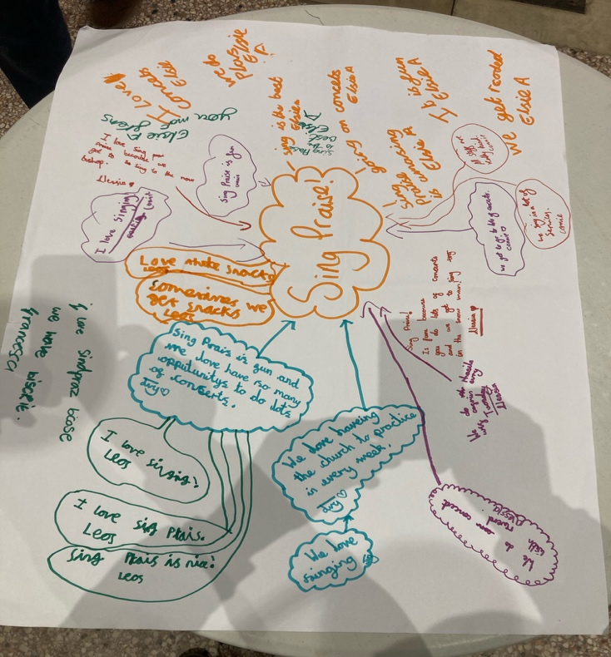
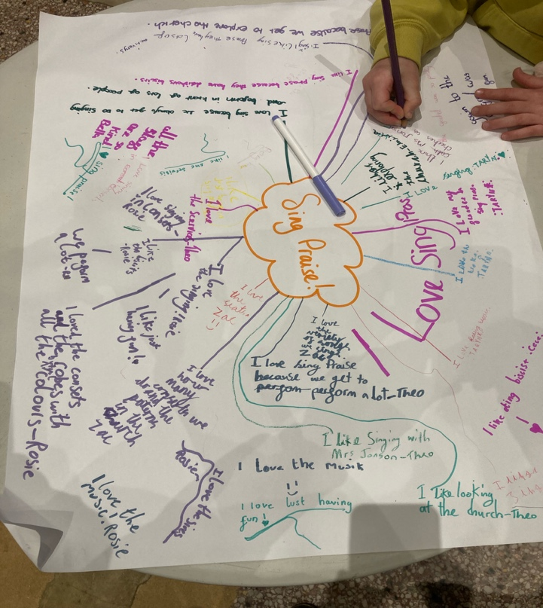
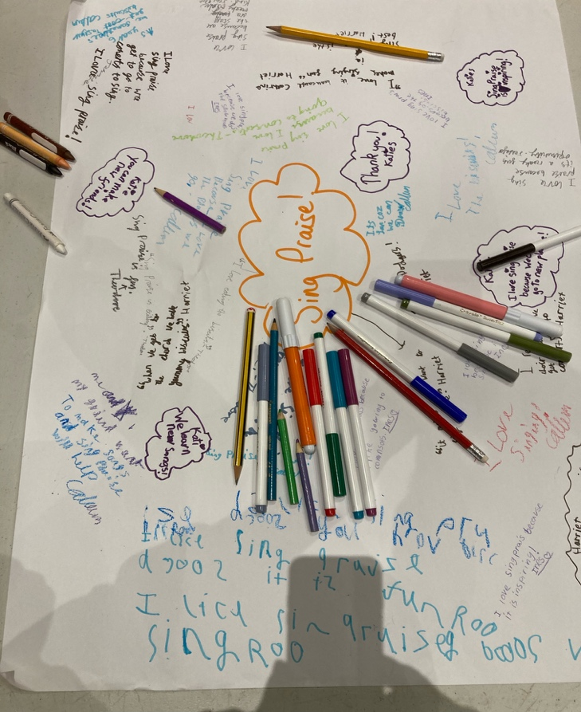
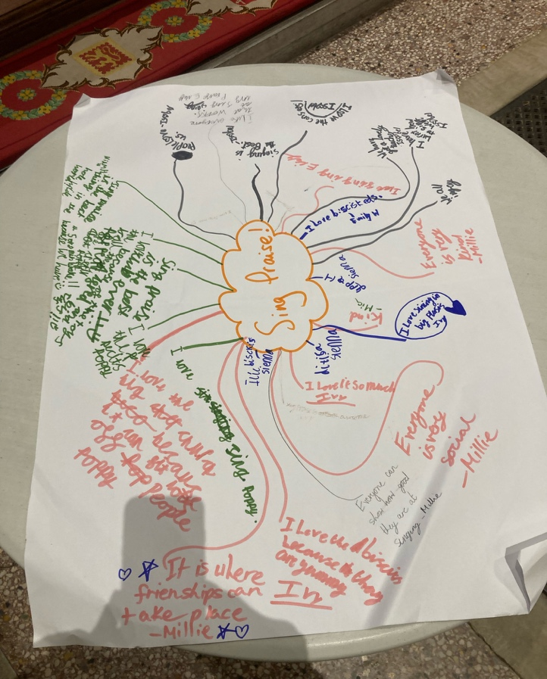
What our Children like about Sing Praise

